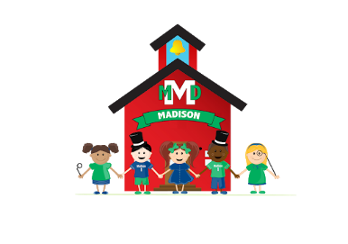
Madison Early Childhood 2022-2023 School Supply List

1 full-sized backpack

1 full set of extra clothing--please put in a Ziplock bag with your child’s name on it

One headshot photo of child to be emailed to child’s teacher

Package of Pull Ups with tabbed sides if your child is not potty trained.

1 24-ct. box Crayola Crayons
1 10 ct Crayola Markers
1 pack of 6 glue sticks
2 bottles of Elmer's School Glue
1 set Crayola watercolor paints
1 4-pack Play-Doh 15-oz. size
1 100-ct. boxes 5 oz. Dixie Cups—NOT 3 oz.
2 boxes facial tissue
1 package napkins
1 rolls paper towels
1 100-ct. package baby wipes 1 box of 2 gallon size baggies-boys
1 box of gallon size baggies-boys
1 box of sandwich size baggies-girls
1 box of quart size baggies-girls

PFA Students do not need to provide supplies. We will furnish any needed supplies through grant funding.

