Sandwich, Maple Pancake, WG, Chicken Sausage & Cheese, IW (#9126)
- PDF
- 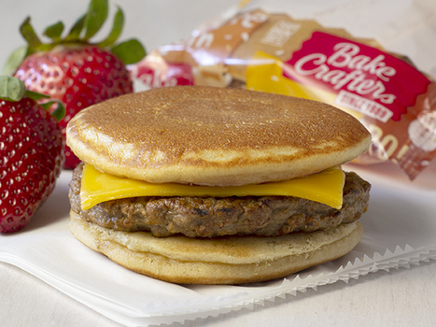

Nutrition Facts
1 Sandwich (81g)
Serving size
Amount per serving
Calories
180
% Daily Value*
Total Fat 7g | 10%
Saturated Fat 2g | 11%
Trans Fat 0g
Cholesterol 30mg | 10%
Sodium 350mg | 15%
Total Carbohydrate 18g | 7%
Dietary Fiber 1g | 4%
Sugars 7g
Includes 7g Added Sugars | 14%
Protein 10g
Vitamin D 0mcg | 0%
Calcium 80mg | 6%
Iron 0.7mg | 4%
Potassium 160mg | 4%
* The % Daily Value (DV) tells you how much a nutrient in a serving of food contributes to a daily diet. 2,000 calories a day is used for general nutrition advice.
- PDF
This delicious sandwich is definitely in the running for being the most perfect breakfast! A fully cooked chicken sausage patty between two wholegrain mini maple pancakes, plus a slice of cheese! It's so tasty, no syrup will be needed.

INGREDIENTS
Whole Wheat Flour, Enriched Wheat Flour (Wheat Flour, Niacin, Reduced Iron, Thiamine Mononitrate, Riboflavin, Folic Acid), Sugar, Maple Chips (Sugar, Wheat Flour, Soybean Oil, Cellulose Gum, Natural Flavor), Contains 2% or less of: Baking Soda, Buttermilk Solids, Dextrose, Egg, Mono Calcium Phosphate, Natural Maple Flavor (Water, Propylene Glycol, Natural Flavors), Salt, Sodium Aluminum Phosphate, Soybean Oil, Lecithin, Whey Powder. Chicken Sausage: Chicken, Water, Seasoning (Salt, Spices, Dextrose, Sugar). American Cheese: Cultured Skim Milk and Milk, Water, Sodium Citrate, Salt, Potassium Citrate, Annatto and Paprika (color), Cream, Enzymes, Sorbic Acid (preservative), Sunflower Lecithin, (anti-sticking agent).

ALLERGENS & DISCLOSURES
Contains egg, milk, soy, and wheat ingredients.
Contains bioengineered food ingredients.
This product is produced in a nut-free facility.

